## Develop Alexa Skill for COVID-19 Recommendations

### Introduction

* Overview

Amazon allows developing custom skills for **Alexa** which makes this feature more fun. Skills are some sort of applications which can be used by Echo devices. To use those skills the user must say a wake-up word and activate the skill. All interactions with the skill happens by voice.

* Purpose

To create an Alexa skill that responds to voice commands. This skill will provide details about COVID-19 in India, assist the user in recognising symptoms and provide all-encompassing advice. The skill answers on "open covid info". Further, the details provided by the patient will be stored in DynamoDB. AWS Lambda and IAM services are used to accomplish this.

### Result

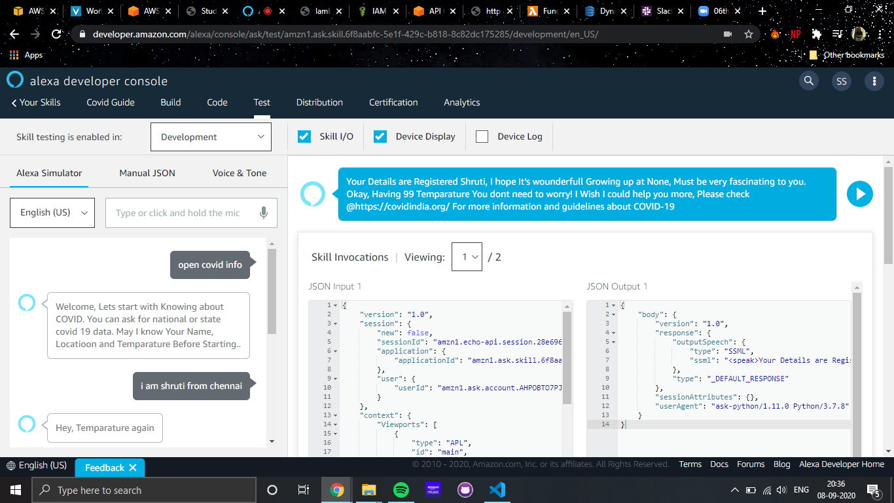

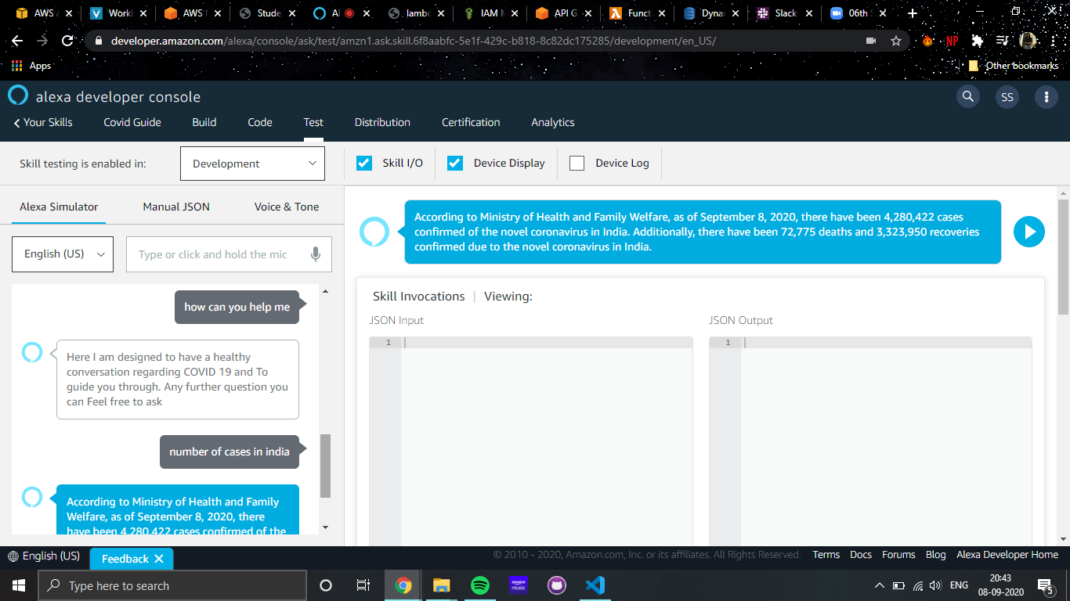

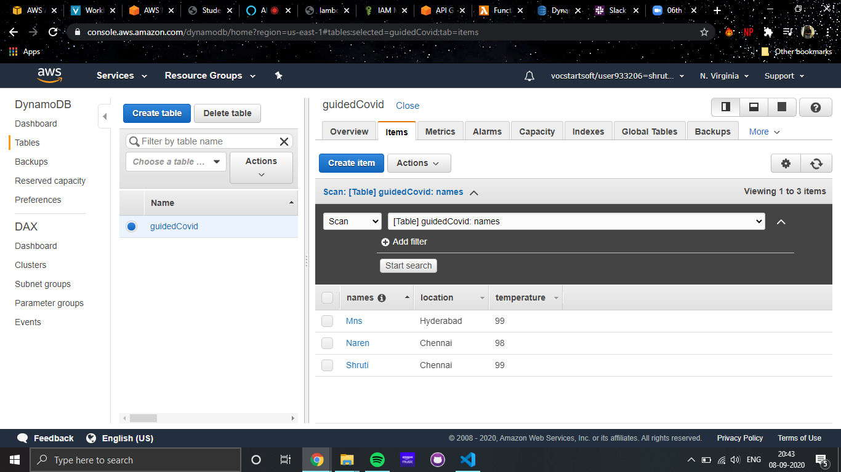

### Applications

* Users with an Alexa-enabled device, such as Amazon Echo and Echo Dot, can enable the skill "Covid Guide" to get information about the pandemic.
* Providing comprehensive information on the COVID-19 pandemic to make the public aware of new updates.
* Customers in India can use Alexa to check their symptoms for COVID-19 at home.

### Conclusion

This Alexa skill can be, thus, used from home to obtain accurate and timely information from official government and news sources globally including information about symptoms, prevention, coping, treatment, and more.

### Future Scope

In many ways, Alexa acts as a search engine but without the need for an extra device. There’s also a more personal element to the voice interactions. Given the hands-free nature of Alexa, this voice tech skill can also be used inside hospitals as a communication tool.